**PLATE DETECTION WITHOUT HELMET**

*1T.Sai varsh kumar , 2M.Baswanth ,3 D. Sandeep naik, 4Mr B.Naresh*

# *1,2,3bachelor Degree, Cse,* *Jayamukhi Institute Of Technological Sciences Narsampet, Warangal.*

*Mr B.Naresh ,Associate Professor, bachelor Degree, Cse, Jayamukhi Institute Of Technological Sciences Narsampet, Warangal*

**ABSTRACT:**

T The development of an automated and efficient cyber-threats detection approach is one of the key difficulties in cybersecurity. In this study, we describe an artificial intelligence (AI) method based on artificial neural networks for detecting cyber threats. The suggested solution uses a deep learning-based detection method to improve cyber-threat identification by breaking down a large volume of recorded security events into individual event profiles.

For this project, we created an AI-SIEM system that combines event profiling for data pre-treatment with several artificial neural network techniques, such as FCNN, CNN, and LSTM. The system has a strong emphasis on separating real positive warnings from false positive alerts, assisting security analysts in quickly responding to cyber threats.

The authors run every experiment in this paper on two benchmark datasets (NSLKDD and CICIDS2017) as well as two real-world datasets. We conducted tests utilising the five common machine-learning methods (SVM, k-NN, RF, NB, and DT) to assess the performance in relation to existing approaches. The experimental findings of this study confirm that our suggested methods can be used as learning-based models for detecting network breaches and demonstrate that, when applied in the real world, they outperform traditional methods based on machine learning.

**INTRODUCTION:**

We come across numerous incidents where motorcyclists get severely injured simply because they didn’t wear safety helmets. This negligence has caused a threat to many innocent lives. In India, six two-wheeler riders die every hour in road accidents. Despite having strict traffic regulations, people still neglect the importance of wearing a helmet. Also, the existing surveillance system requires significant human assistance and humans are prone to make mistakes. So automating this system is highly desirable. For doing so, we used object detection deep learning algorithms like YOLOv5. We are dealing with a variety of motorcyclists with distinct colors of clothes, helmets, and angles of motorcyclists. To achieve this, we require a deep neural network that will help to determine the

motorcyclist very accurately. We mainly aim to collect a database of all the motorcyclists who have violated the rules. One of the key problems we faced was determining whether the person is wearing a helmet or not and to differentiate between biker and pedestrian. To solve this problem, we have come up with two methods for finding the same. In the first method, we check the overlap between the classes and create a link between the bike rider and the number plate. In the second method, depending upon the height of the motorcycle bounding box, it will check if a helmet class exists at a particular distance above the motorcycle. In conclusion, the system will determine whether the motorcyclist is wearing a helmet or not. And depending upon the answer, it would extract the number plates of those motorcyclists

who are not wearing helmets

**RELETED WORK:**

Title: “Helmet presence classification with motorcycle detection and tracking,” Abstract: Helmets are essential for the safety of a motorcycle rider, however, the enforcement of helmet wearing is a time-consuming labour intensive task. A system for the automatic classification and tracking of motorcycle riders with and without helmets is therefore described and tested. The system uses support vector machines trained on histograms derived from head region image data of motorcycle riders using both static photographs and individual image frames from video data. The trained classifier is incorporated into a tracking system where motorcycle riders are automatically segmented from video data using background subtraction. The heads of the riders are isolated and then classified using the trained classifier. Each motorcycle rider results in a sequence of regions in adjacent time frames called tracks. These tracks are then classified as a whole using a mean of the individual classifier results. Tests show that the classifier is able to accurately classify whether riders are wearing helmets or not on static photographs. Tests on the tracking system also demonstrate the validity and usefulness of the classification approach. Title: “Vehicle detection, tracking and classification in urban traffic,” Abstract: This paper presents a system for vehicle detection, tracking and classification from roadside CCTV. The system counts vehicles and separates them into four categories: car, van, bus and motorcycle (including bicycles). A new background Gaussian Mixture Model (GMM) and shadow removal method have been used to deal with sudden illumination changes and camera vibration. A Kalman filter tracks a vehicle to enable classification by majority voting over several consecutive frames, and a level set method has been used to refine the foreground blob. Extensive experiments with real world data have been undertaken

to evaluate system performance. The best performance results from training a SVM (Support Vector Machine) using a combination of a vehicle silhouette and intensity-based pyramid HOG features extracted following background subtraction, classifying foreground blobs with majority voting. The evaluation results from the videos are encouraging: for a detection rate of 96.39%, the false positive rate is only 1.36% and false negative rate 4.97%. Even including challenging weather conditions, classification accuracy is 94.69%. Title: “Automatic Number Plate Recognition System”, Abstract: Automatic Number Plate Recognition (ANPR) is an image processing technology which uses number (license) plate to identify the vehicle. The objective is to design an efficient automatic authorized vehicle identification system by using the vehicle number plate. The system is implemented on the entrance for security control of a highly restricted area like military zones or area around top government offices e.g. Parliament, Supreme Court etc. The developed system first detects the vehicle and then captures the vehicle image. Vehicle number plate region is extracted using the image segmentation in an image. Optical character recognition technique is used for the character recognition. The resulting data is then used to compare with the records on a database so as to come up with the specific information like the vehicle’s owner, place of registration, address, etc. The system is implemented and simulated in Matlab, and it performance is tested on real image. It is observed from the experiment that the developed system successfully detects and recognize the vehicle number plate on real images.

**EXISTING SYSTEM:**

Title: “Faster R-CNN” Abstract: This article gives a review of the Faster R-CNN model developed by a group of researchers at Microsoft. Faster R-CNN is a deep convolutional network used for object detection, that appears to the user as a single, end-to-end, unified network. The network can accurately and quickly predict the locations of different objects. In order to truly understand Faster R-CNN, we must also do a quick overview of the networks that it evolved from, namely R-CNN and Fast R-CNN. The article starts by quickly reviewing the region-based CNN (R-CNN), which is the first trial towards building an object detection model that extracts features using a pre-trained CNN. Next, Fast R-CNN is quickly reviewed, which is faster than the R-CNN but unfortunately neglects how the region proposals are generated. This is later solved by the Faster R-CNN, which builds a region-proposal network that can generate region proposals that are fed to the detection model (Fast R-CNN) to inspect for objects. Title: “Automatic detection of bike-riders without helmet using surveillance videos in real-time,” Abstract: In this paper, we propose an approach for automatic detection of bike-riders without helmet using surveillance videos in real time. The proposed approach first detects bike riders from surveillance video using background subtraction and object segmentation. Then it determines whether bike-rider is using a helmet or not using visual features and binary classifier. Also, we present a consolidation approach for violation reporting which helps in improving reliability of the proposed approach. In order to evaluate our approach, we have provided a performance comparison of three widely used feature representations namely histogram of oriented gradients (HOG), scale-invariant feature transform (SIFT), and local binary patterns (LBP) for classification. The experimental results show detection accuracy of 93.80% on the real world surveillance data. It has also been shown that proposed approach is computationally less expensive and performs in real-time with a processing time of 11.58 ms per frame.

**PRAPOSED SYSTEM:**

We are dealing with a variety of motorcyclists with distinct colors of clothes, helmets, and angles of motorcyclists. To achieve this, we require a deep neural network that will help to determine the motorcyclist very accurately. We mainly aim to collect a database of all the motorcyclists who have violated the rules. One of the key problems we faced was determining whether the person is wearing a helmet or not and to differentiate between biker and pedestrian. To solve this problem, we have come up with two methods for finding the same. In the first method, we check the overlap between the classes and create a link between the bike rider and the number plate. In the second method, depending upon the height of the motorcycle bounding box, it will check if a helmet class exists at a particular distance above the motorcycle. In conclusion, the system will determine whether the motorcyclist is wearing a helmet or not. And depending upon the answer, it would extract the number plates of those motorcyclists who are not wearing helmets.

**RESULT:**

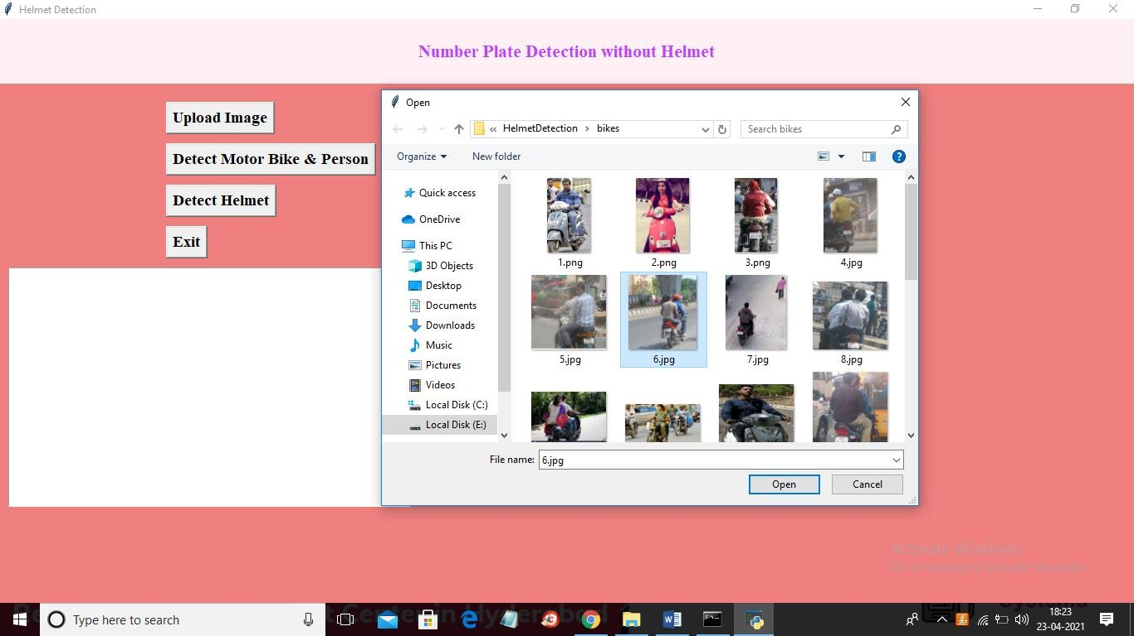



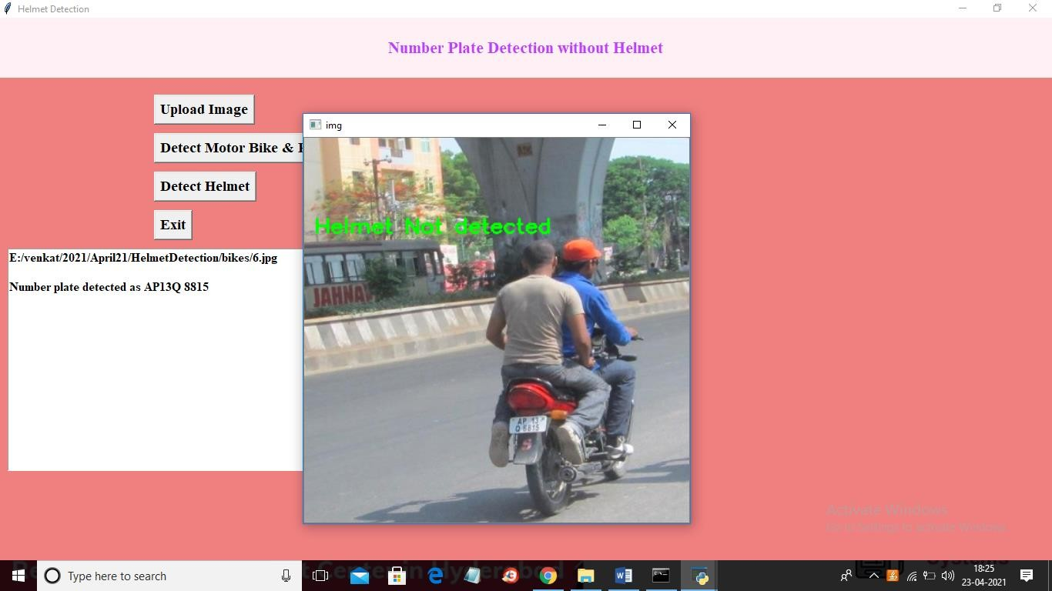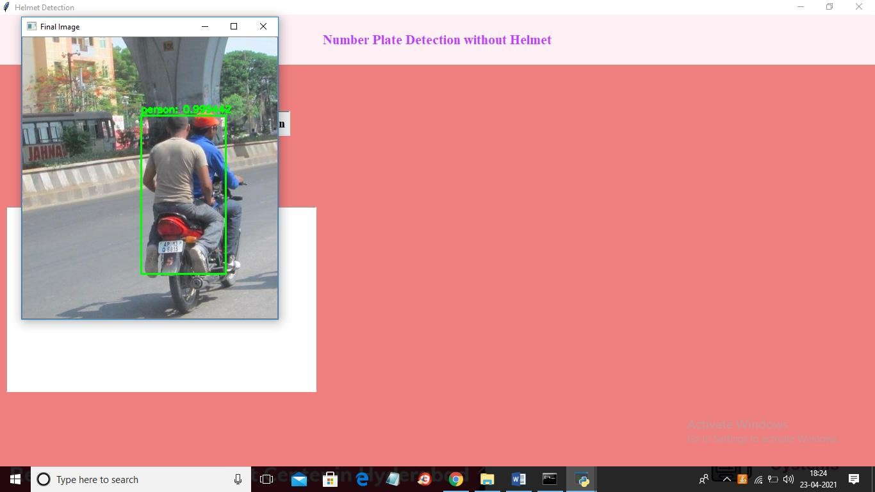

**CONCLUSION:**

We use the YOLOv5 Algorithm which is considered to be the best in real-time object detection algorithm. We have used two methods for detecting whether the motorcyclist is wearing a helmet or not and proceeded with the extraction of the number plate. This number plate character was displayed in text format. This text format is stored in a sheet for violating the law of not wearing a helmet. We achieved a mAP of 0.995 for detecting objects and overlapping conditions make our work different from any others. Our project makes this system autonomous and makes it easier for the authority to penalize people.

**REFERENCES:**

1. J. Chiverton, “Helmet presence classification with motorcycle detection and tracking,” Intelligent Transport Systems (IET), vol. 6, no. 3, September 2012.
2. Z. Chen, T. Ellis, and S. Velastin, “Vehicle detection, tracking and classification in urban traffic,” in Procs. of the IEEE Int. Conf. on Intelligent Transportation Systems (ITS), Anchorage, AK, Sept 2012.
3. C. Patel, D. Shah, A. Patel, “Automatic Number Plate Recognition System”, Article in International Journal of Computer Applications, May 2013.
4. Shaoqing Ren, Kaiming He, Ross Girshick, Jian Sun, “Faster R-CNN” Submitted on 4 Jun 2015 (v1), last revised 6 Jan 2016.
5. K. Dahiya, D. Singh, and C. K. Mohan, “Automatic detection of bike-riders without helmet using surveillance videos in real-time,” in 2016 International Joint Conference on Neural Networks (IJCNN), July 2016.
6. Fan Wu, Guoquing Jin, “Helmet Detection Based On Improved YOLO V3 Deep Model”, in IEEE 16th International Conference on Networking, Sensing and Control (ICNSC), May 2019.
7. Felix Wilhelm Sieberta, Hanhe Linb "Deep Learning-Based Safety Helmet Detection in Engineering Management Based on Convolutional Neural Networks", Department of Psychology and Ergonomics, Berlin, Germany, 2019.
8. Yonten J., Panomkhawn R., Rattapoom W., “Real-time number plate detection for non-helmeted motorcyclist using YOLO”, Received 29 November 2019; received in revised form 3 June 2020; accepted 31 July 2020, Available online 22 August 2020.
9. A. Adil, H. S. Umer, M. Z. Khan, “Automatic Helmet Violation Detection of Motorcyclists from Surveillance Videos using Deep Learning Approaches of Computer Vision” in International Conference on Artificial Intelligence (ICAI), Pakistan, April 2021.
10. Tushar Goel, Dr. K.C. Tripathi, Dr. M.L. Sharma, “Single Line License Plate Detection Using OpenCV And Tesseract”, International Research Journal of Engineering and Technology (IRJET), May 2020.
11. Ritik Singh, Shubham Shetty, Gaurav Patil, Pramod J. Bide, “Helmet Detection Using Detectron2 and EfficientDet, 12th International Conference on Computing Communication and Networking Technologies (ICCCNT), July 2021.
12. Abhinu C G, Aswin P, Kiran Krishnan, Bonymol Baby, Dr. K S Angel Viji, “Multiple Object Tracking using Deep Learning with YOLO V5”, in International Journal of Engineering Research & Technology (IJERT), August 2021.
13. Open Images Dataset (OIDv6): https://storage.googleapis.com/openimages/web/visualizer/inde x.html?set=train&type=segmentation&r=false&c=%2Fm%2F0 1d380
14. Makesense (Image Annotation Tool): https://www.makesense.ai/